Amazon SQS

A Message Queuing Service

Case Study



**Introduction**

Amazon Simple Queue Service (Amazon SQS) offers a secure, durable, and available hosted queue that lets you integrate and decouple distributed software systems and components. Amazon SQS offers common constructs such as [dead-letter queues](https://docs.aws.amazon.com/AWSSimpleQueueService/latest/SQSDeveloperGuide/sqs-dead-letter-queues.html) and [cost allocation tags](https://docs.aws.amazon.com/AWSSimpleQueueService/latest/SQSDeveloperGuide/sqs-queue-tags.html). It provides a generic web services API that you can access using any programming language that the AWS SDK supports.

**How it’s works**

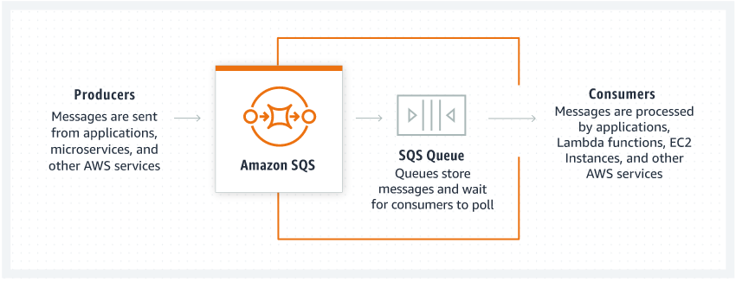

**Step by step configuration of Amazon SQS service.**

**Open Your Amazon Management console**

* Search simple Queue service in search box
* Click on it and open it

**In Amazon SQS service dashboard**

* Click on Create query

In Create Queue

* Select Type – Standard or FIFO first in first out
* Name the Queue

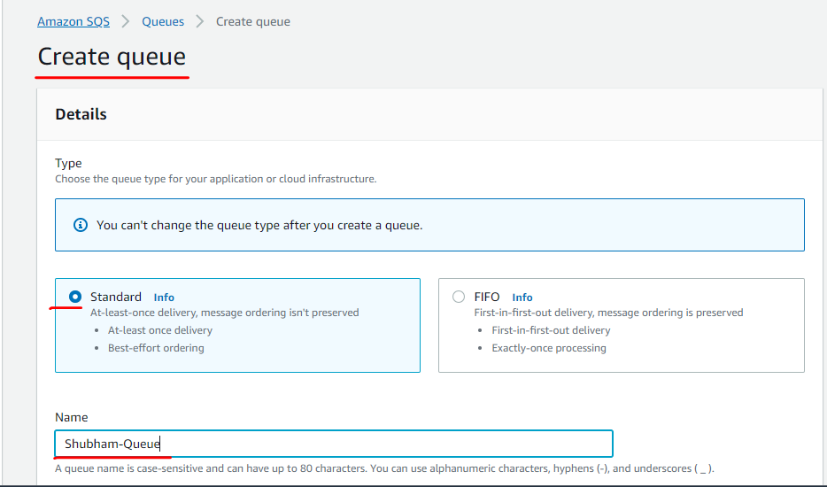

In configuration

* Keep all maximum things default
* Like Visibility timeout , Delivery delay and wait time , etc.

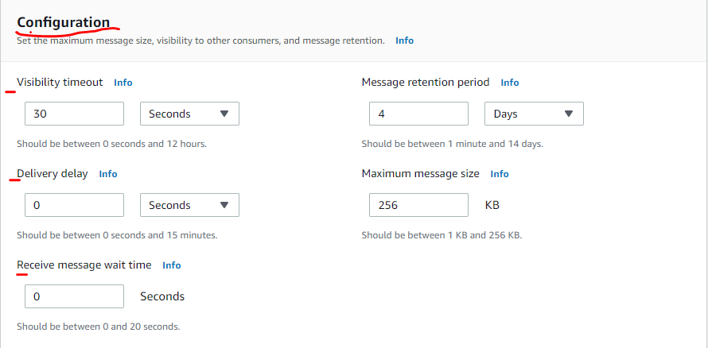

In Access policy

* Choose method
* Keep other things default
* If you have any other user like IAM user you can choose next option but in this case I am using “only the queue owner”

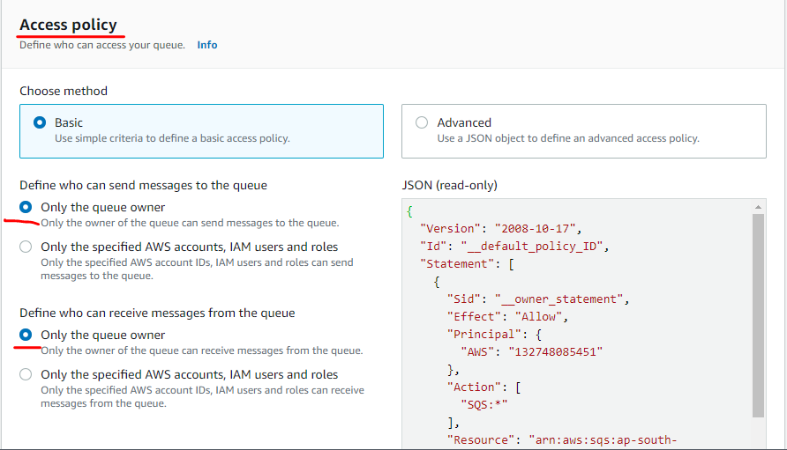

Redrive allow policies , encryption, dead letter queue all things disable.

If required you can enable it. As pe you need.

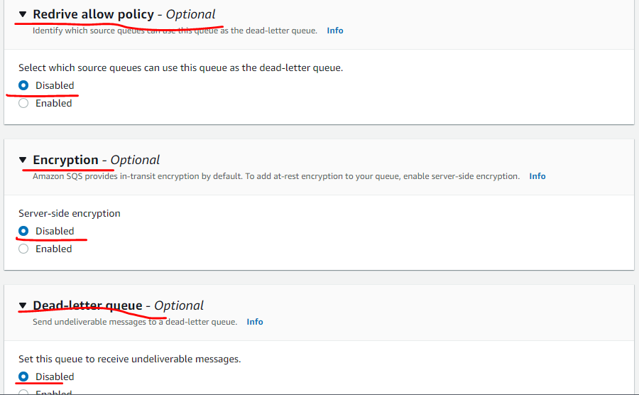

Click on Create queue option

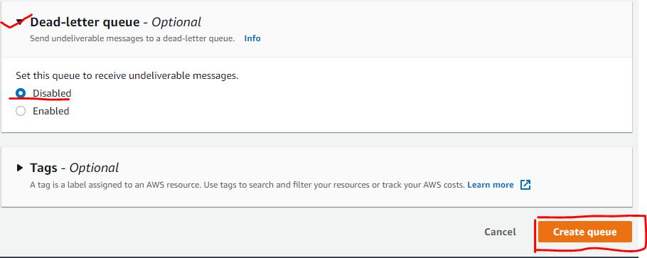

Your Queue is created with name “Shubham-Queue”

* You can read and see all details available in details section as shown in figure.
* Like ARN number
* Name
* Type, etc

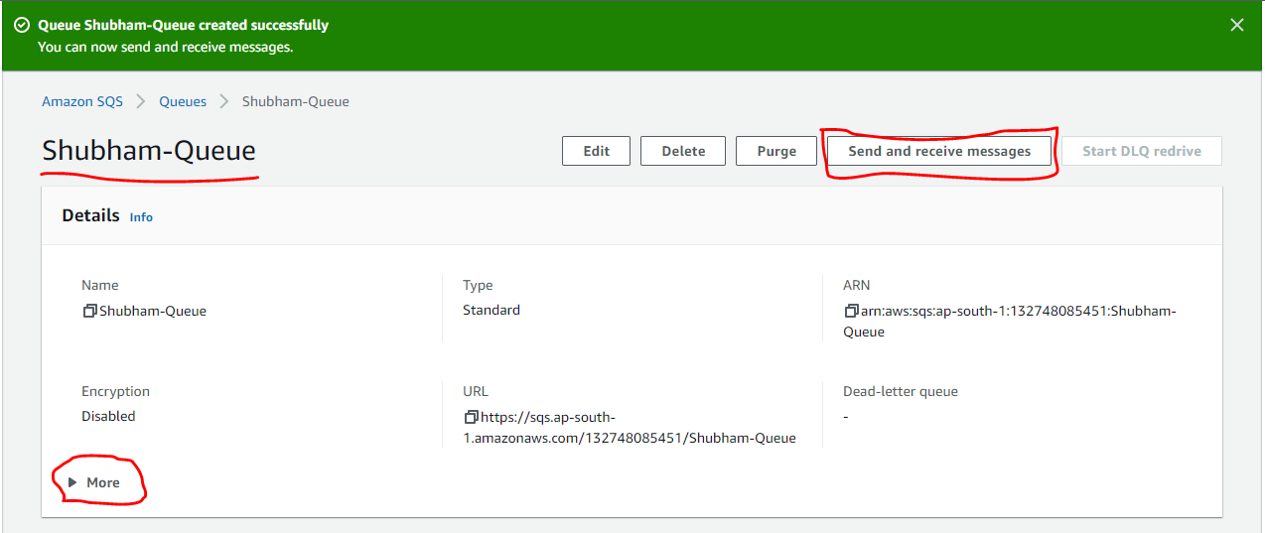

Check in

* SNS subscription
* Lambda triggers
* Dead-letter-queue
* Monitoring and other stuff

Click on Send and Received message

In Send and receive message

* You can write your message body
* Mention delivery delay time
* Message attributes if any

In receive message you can see no message is came yet its 0

Now click on Send Message

You will get this notification

Now again check in your received mail you will see one message is visible there 1

* Click on Poll for message

Click on Message ID that blue colour name

In body you can see the message is visible

In Details you can see all details about message

In Attributes you can see previously mentioned name and value of attributes.

If you want to delete this message

* Select the message
* Click on Delete

Click on delete

In message

* Click on clear message
* And then click on queues

Select Queue

Click on Delete

Type delete in box

Click on delete

In green colour ribbon one pop up message will come.

That Queue Shubham-Queue(Queue_Name) has been deleted successfully.

